Title of Full Paper Presentation
(Times New Roman, 14 pt, bold, capitalized each word)

Presenter’s Complete Name ¹, Co-author complete name ², Corresponding author complete name ^{1,3,*} and Michael N. Choi (Times New Roman, 11 pt, plain text, underline name of presenter and asterisk for the corresponding author)

¹ Department, Faculty/College, University/Institution, Address, Zip Code, Country (11 pt, italics)
² Department of Chemical Engineering, Gokongwei College of Engineering, De La Salle University, 2401 Taft Avenue, Manila 1004, Philippines
³ Department of Civil Engineering, Faculty of Engineering and Technology, Kunsan National University, 588 Daehak-ro, Miryong-dong, Gunsan, Jeonbuk 573-701, South Korea

*Corresponding author: rsce2018.dlsu@gmail.com (Do not underline email address, Times New Roman, 11 pt, plain text)

ARTICLE INFO |  | ABSTRACT
Received (c/o RSCE 2018)  Received in revised form  (c/o RSCE 2018)  Accepted (c/o RSCE 2018)  Keywords  acid-catalyzed hydrolysis, coarse ceramic aggregate, hydrogenation, fly ash, waste material |  | This is the format for the preparation of the full paper for the 25th Regional Symposium on Chemical Engineering (RSCE 2018). Please follow this template strictly. This document can be used as a template for your preparation. The abstract should be a single paragraph describing the objectives, summary of highlights of the research and should be between 150-200 words only. Use Times New Roman, 10 pt, italic. For the keywords, list a maximum of 4-6 phrases. All small letters, separated by a comma and ends with a period. Use Times New Roman, 8 pt, italic for the keywords.

- INTRODUCTION

Kindly follow this template in the preparation of your full paper. The body of the full paper should be formatted into two columns (Width 23.93 ch and Spacing 2.01 ch with equal column width). Only Times New Roman font is accepted and Symbol font for Greek letters and other symbols. The font size to be used is 10 point size. Full paper should contain the title, authors, affiliation of each author, keywords and abstract, main body (introduction, material and methods, results and discussion, conclusion), acknowledgment (optional) and references. Length of the full paper must not exceed 6 pages. The final papers will be published in the RSCE 2018 Conference Proceedings and will be distributed to registered participants during the conference. Authors should be responsible of the image quality and readability when modifying the images. Use Letter paper (21.59 cm × 27.94 cm) with the margins: top 3 cm, bottom 1.8 cm, left 2.5 cm and right 1.5 cm. Paragraphs are justified on both left and right margins and the space between lines is 1.15. Paragraph tab should be set at 0.5 cm.
For the section headings, use Roman Numerals starting with I. Example: I. INTRODUCTION. Leave a space after the section heading then start with the subsection heading. For the ordering of the subsection, use Arabic numerals. Example: 1. Materials and Reagents, 2. Modeling, 3. Effect of temperature, and so on. One blank space should be given between section headings and between subsection headings.

- MATERIAL AND METHODS

- Materials and Reagents
For the titles of the subsection headings, capitalize the beginning of each word and use Times New Roman, 10 pt size, plain text). No space is needed between the subsection heading and the first paragraph.
For abbreviations and acronyms, define them the first time they are used in the body, even after they are defined in the abstract. As much as possible, do not use abbreviations or acronyms in the titles or headings.

- Experimental Set-up
For figures, fit the figures to fit the column. For large figures, the page width can be occupied, however, the succeeding text retain the two-column format. Figures must be clear and should not be crowded with unnecessary details and labels. It must be centered and each figure must be followed and preceded by a blank line. Figures and other images can be colored or black and white.

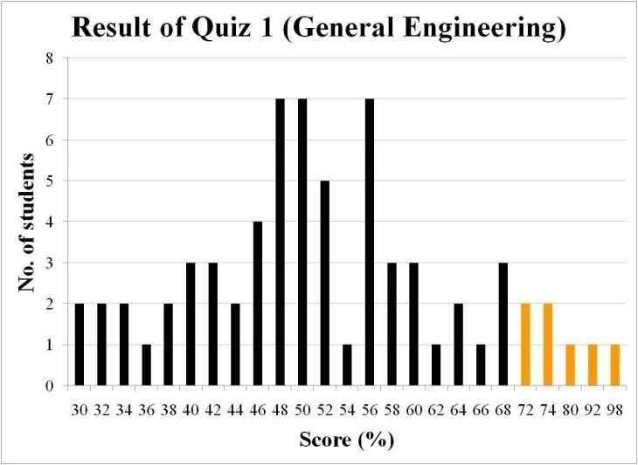
Figure 1. Typical result of general engineering exam from Section X.

Every figure must be accompanied by figure number (in sequence starting from Figure 1, Figure 2, Figure 3, etc). Figure number should be center-aligned and positioned just below the figure. Use Times New Roman, 9 pt size, plain text. Capitalize only the first letter of the figure caption.

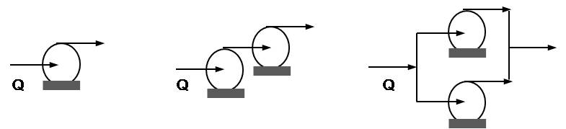
Figure 2. Typical pump arrangements.

Cite figures in the text as follows: The variation of the ash components in the sample is shown in Fig. 2. As shown in Fig. 3(a), the size of the particle was reduced compared to that shown in Fig. 3(b). Each table must be followed and preceded by a blank line.

- RESULTS AND DISCUSSION

- Tables
For tables, table number and its caption should be on top of the table and left-aligned as shown. The table caption should be Times New Roman, 9 pt size and plain text. Table must be labeled in sequence starting from Table 1, Table 2, Table 3, and so on. The data on the table should not be smaller than 8 pt size.
Cite tables in the text as follows: The variation of the activation energy of the catalyzed reactions is shown in Table 1. As shown in Table 1, the activation energy decreases as the loading of the catalyst was increased from 5 wt% to 15 wt%.

Table 1. Activation energies of the catalyzed reaction
 | Loading (wt%)
 | 5% | 10% | 15%
Catalyst | Activation energy (kJ⋅mol^{–1})
K₂CO₃ | 107.2 | 101.8 | 95.3
FeSO₄ | 138.7 | 131.1 | 130.9

- Equations in the Main Body

Equation should be prepared using MathType, Equation Editor or other equation softwares. A table may be inserted with two unequal columns where the first column (wider) will contain the equation and the other column will contain the equation number (both equation and equation number center-aligned in the table column). The equation must be followed and preceded by a blank line.

$$\frac{1}{1−X}\frac{\text{dX}}{\text{dt}}=k{\left(1−X\right)}^{\frac{2}{3}}$$ | (1)

After the construction and labelling of the equation, hide the border line of the table to yield the following:

$$\frac{1}{1−X}\frac{\text{dX}}{\text{dt}}=k{\left(1−X\right)}^{\frac{2}{3}}$$ | (1)

where X = fractional conversion of carbon in the char at any time, k = shrinking-core model constant (h^{–1}) and t = time of gasification (s).

Cite equations in the text as follows: The reaction constant can be calculated using Eq. 1. Label chemical reactions as follows:

CH3COOH  CH3COO^{–1} (aq) + H⁺ (aq) | (R1)

Cite reaction in the text as follows: The ionization reaction (R1) results to the formation of ions in aqueous solutions.

- CONCLUSION

Whenever possible, the full paper should be checked by all authors prior to submission to eliminate errors that may have been neglected by one author.

ACKNOWLEDGMENT
This research was financially supported by Ministry of Knowledge and SK Energy (EN-1023-2345).

REFERENCES
The following template in listing the references was based from the template given by the organizers of RSCE 2015. Number the citations consecutively using a square backet (e.g. [1], [2], [3] and so on). Cite references in the main body as [1] rather than “Ref. [3]” or “reference [3]” except at the beginning of a statement: “Ishida and Wen [1] uses a fluidized-bed gasifiers”. If a citation refers to several references, include them in one pair of square bracket (e.g. The use of ionic liquids has been studied extensively by numerous authors [1-3,7, 10-11].
For three authors or more, use et al. References that have not been published officially must be cited as “unpublished”. Papers that have been accepted for publication should be cited as “in press”.
For various types of references see the examples below. No need to identify type of reference.
Proceeding Papers
- Brook, W.J. Modeling Design and Control of Flexible Manipulator Arms: A Tutorial Review. Proceedings 29th IEEE Conference On Decision and Control, San Francisco, CA, 1990, pp. 500-506.
Journal Papers
- Ishida, M. and Wen, C.Y. Effectiveness factors and instability in solid-gas reactions, Chemical Engineering Science 23, 1968, 125-137.
- Bungay, V.C. and Song, B.H. 알칼리금속염과 철황산염을 촉매로 한 갈탄의 CO₂ 가스화반응에서기체-고체 반응모델을 적용한 촉매활성의 비교 [Comparison of catalytic activity through gas-solid reaction models in CO₂ gasification of lignite with alkali metal salts and iron sulfate], Journal of Energy Engineering 23(1), 2014, 58-66.
Books
- David, F.G., ed. Handbook of applied powder nanotechnology. 3rd ed. New York, Mc-Hraw-Hill, 1999.
- dela Cruz, J.C., Mabini, A.L. and Rizal, J.M. The youth of tomorrow. 2nd ed. Manila, Rex Bookstore Inc., 2011.
In press citations
- Hughes, K. W., Chin, C.S., Shieh, L.S. and Fang, D.G.M. The utilization of SiO₂ in ash as catalyst to lignite combustion in a thermobalance reactor. Journal of Catalysis A (in press).
- Eggen, F.A. and Schack, R.T. Educational Psychology. 2nd Ed. New-York, Prentice-Hall Inc., 2002, pp. 34-48.
From the internet
- Available online at www.dost.gov.ph/en/coal.html

