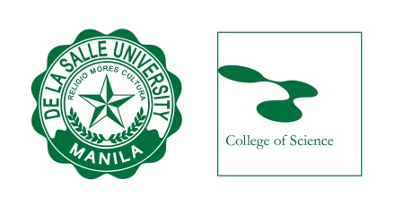
PROGRAM OF STUDY
NAME
Master of Science in Biology (MS BIO)

REQUIREMENTS:

Basic courses | 9 units
Major courses | 15 units
Specialization/Elective | 6 units
Seminar | 1 unit
ComprehensiveExam | 0 unit
Thesis | 6 units
TOTAL | 37 units

Scholarship:

AY 2019-2020
Term 1 | Term 2 |  | Term 3
Bioethics  (BIO503M, 3 units)  Advanced Physiology Lecture  (BIO605M, 2 units)  Advanced Physiology Laboratory  (BIO604M, 1 unit)  Advanced Systematics Lecture  (BIO607M, 2 units)  Advanced Systematics Lecture  (BIO606M, 1 unit) | Biostatistics  (BIO501M, 3 units)  Advanced Genetics Lecture  (BIO603M, 2 units)  Advanced Genetics Laboratory  (BIO602M, 1 unit)  Elective 1  (3, units)  Elective 2  (3 units) |  | Methods of Biological Research  (BIO505M, 3 units)  Advanced Ecology Lecture  (BIO601M, 2 units)  Advanced Ecology Laboratory  (BIO600M, 1 unit)  Cell Biology  (BIO609M, 3 units)  Seminar  (BIO852M, 1 unit)
Total: 9 units | Total: 12 units |  | Total: 9 units
AY 2020-2021
Term 1 | Term 2 |  | Term 3
Written Comprehensive Examinations  (BIO511W, BIO601W, BIO605W, BIO607W, 0 unit) | Thesis Writing 1  (BIO876M, 6 units)  Proposal Defense |  | Thesis Writing 2  (BIO877M, 0 unit)  Final Defense
Total: 0 units | Total: 6 units |  | Total: 0 units
Prepared by:  DR. MA. CARMEN ABLAN LAGMAN  Graduate Program Coordinator  Biology Department  Date: 8 August 2018 |  | Conforme:  STUDENT NAME  MS in Biology  ID #:  Date: 8 August 2018

Note: (1) Research courses may be taken at any term
(2) For electives, please check the list from the MS Biology Course Tracking
(3) Non-highlighted course are offered only on the given term
(4) Comprehensive exams can only be taken after all coursework is done
(5) Methods of Biological Research and Seminar are to be taken on the same term
(6) Methods of Biological Research should be enrolled using the Special Project/ Practicum form and with your thesis adviser

