Evaluation of the Buffering Capability of β-Chloro-Propionic Acid–Sodium β-Chloro-Propionate
System In A Low pH Geothermal Brine

Yolanda de la Peña-Brondial
Chemical Engineering Department, De La Salle University-Manila
brondialy@dlsu.edu.ph

ABSTRACT

A potential method for commercializing high-enthalpy acidic geothermal wells was explored in this study by raising the pH of the geofluids to equal or greater than 3.5, pH levels considered by geothermal reservoir engineers to be non-corrosive to low carbon steel. The pH buffering was modeled using stepwise regression and was simplified using the software Design Expert 6. The β-chloro-propionic acid-Sodium β-chloro-Propionate (BCPH-NaBCP) was the buffer used in this study. Five design factors and a response factor were considered. The experiments were conducted according to the experimental design at 25ºC≤t≤100ºC and the resulting pH for each combination of factors was measured. The best combination of factors was then used in the bench scale set-up to investigate the possibility of applying pH buffering at high velocity. Results showed that BCPH-NaBCP was useful for fast buffering and could therefore be used to commercialize acidic wells.

INTRODUCTION

The Philippines being part of the “Pacific Ring of Fire” has abundant geothermal energy. It is second to the United States of America in installed geothermal electric capacity, and third behind Mexico in power generation [1]. However, a substantial number of drilled wells produce acidic geofluid with high enthalpy and high wellhead pressure [2]. This acidic geofluid is corrosive to the casing and pipeline network of the steam-gathering system made up of low carbon steel. Its non-condensible gases (NCG) are relatively high in H₂S and CO₂, and its brine is high in SO₄⁻². These substances, aside from being potential hazards, account for the acidity of the geofluid. It becomes imperative therefore, to research and develop methods or techniques by which these acidic wells can be used for power generation. The geothermal industry incurs a huge financial loss with the current practice of plugging and abandoning acidic wells.

THEORETICAL CONSIDERATIONS

The idea of buffering is to adjust the pH of the solution to a non-corrosive level such as pH > 3.5. At this pH, the material of construction of the geothermal well casing and the steam gathering system will not corrode due to acidity [3]. If the brine is buffered and the well is shut-in for sometime, it is expected that as the NCG builds-up, the pressure at the reservoir will increase. It follows that the amount of CO₂ dissolved also increases and the pH is expected to go down. Since the geofluid is buffered, the pH is not appreciably affected.

A buffer, composed of either a weak acid and its strong salt with a strong base or a weak base and its strong salt with a weak acid, has the ability to maintain the pH of a solution between narrow limits [4]. Therefore, a solution that is buffered will have no appreciable change in its pH upon dilution or addition of slight to moderate amounts of a strong acid or base. This ability of a buffer to prevent a significant change in pH is directly related to the total concentration of the buffering substances and to their concentration ratio in terms of moles acid (or base) / moles salt.

EXPERIMENTAL PROCEDURES

For the laboratory tests, five factors were included in the experimental design, e.g. pH geofluid (2.0, 2.5, 3.0), pH BCPH-NaBCP (3.5, 4.0, 4.5), volume BCPH-NaBCP (5-45ml), concentration BCPH-NaBCP (0.01M-0.50M) and temperature of the solution (25ºC – 100ºC). The first four factors were held constant at specified levels and therefore were classified as controllable while the temperatures of the resulting solution was allowed to vary. The response variable was the resulting pH of solution.

Experiments were done based on the experimental design. Since all the acidic wells are plugged and abandoned, the geofluid used was obtained from a geothermal well at the Makban Geothermal Field with an average pH of 6.2 and then acidified with HCl. This was done to maintain the chemical composition of the geofluid instead of preparing a synthetic geofluid. Thermal stability tests, buffer capacity tests to an added H₂SO₄ and the determination of the ßeta value of BCPH-NaBCP solutions were also done.

CONCLUSIONS

The BCPH-NaBCP buffering solutions are capable of raising the pH of the geofluid to a value > 3.5. At this pH, the geofluid is not corrosive to low-carbon steel. The statistical analysis of the laboratory experiments indicates that the model equation is acceptable and that the initial pH of the geofluid, the pH, concentration, and volume of BCPH-NaBCP solution significantly influenced the stable pH of the solution.

Using the optimization method of Design Expert 6, the best combination of factors was used in the bench-scale set-up shown and results showed that BCPH-NaBCP is useful for fast buffering. This means that if BCPH-NaBCP is used for a flowing two-phase geothermal fluid, the desired pH can be attained and can therefore be used to commercialize acidic geothermal wells.

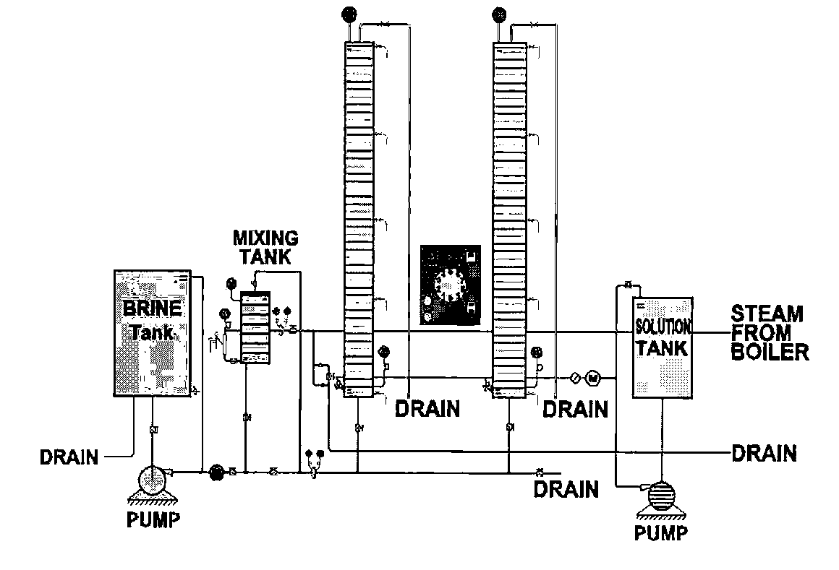
Figure 1. Bench-Scale Set-up for the Simulation of a Geothermal Well
REFERENCES

- Quijano, J.L. 1993. “Current State of Geothermal Energy in Mexico.” Int. Geoth. Assoc. News.
- Brondial, Y.P. and A.A. Puertollano, 2000. “pH Buffering for Acidic Geothermal Wells Utilization.” INHENYERIYA, an International Journal of Engineering. Volume 1, Book 2.
- Abe, M., 1993. “Long Term Use of Acidic Reservoir at Onikobe Geothermal Power Plant.” Proceedings of the 15th New Zealand Geothermal Workshop, 1993. pp 5-10.
- Kenner, C.T. and K.W. Busch, 1979. “Quantitative Analysis.” Macmillan Publishing Company, New York.

